3/8/2018

STAT019 ICA1

Student ID: 14006787 & 17011380

1. **Introduction**

This report is aiming to produce a clustering analysis for characterising the districts of the German city of Dortmund for administrative use. We were given the data measured in 2002 with 170 observations (districts) and 30 variables for demographic and historical information.

1. **Data**
   1. ***Description of the data***

The dataset gives the numbers of unemployed people, area of buildings, births and deaths, moving rate, means of transportation, number of buildings constructed in specific decades, number of people in different age range, number of people by gender and social insurance, benefits information. One important thing to note is that there are 9 variables for buildings_years and 6 for the age groups. It worth to reduce the dimensions of these two variables for better illustration and visualization.

***2.2 Exploratory Analysis***

We commenced by summary statistics for each variable (Figure 1). The ranges of the variables vary significantly, especially for ‘area_building’ which has range of values much greater than the others, which is also proved by the boxplots (Figure 2). Also, the boxplots reveal the fact that there are some outliers in our dataset with values much greater than the average. We then explored the districts by sorting the order and found that “Scharnhorst-Ost” and “Obereving” have occupied most of the maximums, which means these two districts might have larger population in 2002 than other districts, and also contributes more unemployed people, more social insurance, and more cars etc. The City-West has the largest amount of trucks, which in 2002 we may deduce that it was an industrial district with lots of pollution. Additionally, “Marsbruchstrasse” and “Westfalenhutte” have extreme numbers of migrations.

Figure 3 is the correlation table compared between each variable, we can see that many covariates are highly correlated and could present similar things. And some of these associations can be causal, for example number of households can directly influenced the number of children. As seen from Figure 4 and 5 that, there are exactly linearly dependent patterns exist. These high degree of collinearity, which makes the variables not dissimilar, may lead to overrepresentation for the clustering. Therefore, we regarded the correlation that has an absolute value greater than 0.9 being problematic and managed to expurgate or transformed them.

Also, in order to combine the buildings in a more appropriate way, we conducted the clustering for buildings. Since the K-means and hierarchy clustering methods all work awfully, indicating 8 clusters being the best choice while we only got 9 variables for the data. We then calculated the correlation dissimilarity and used a MDS plot (Figure 6) to visualize the possible clusterings. From the plot, we decided to aggregate them into three groups by summing the numbers of buildings until 1900 to 1918; 1919 to 1962; and 1963 to 2001.

***2.3 Dealing with Collinearity***

To treat the high collinearity, we introduced Principal Component Analysis (PCA) that converts the possibly correlated variables into a set of values of linearly uncorrelated variables, for protecting information from directly deleting some relevant but replicated variables. We first examined the performance of PCA by groups, results and the linear combination coefficients used are displayed in Figure 7.   
  
We extracted the first two PCs of age group which have represented more than 95% of the variance. PC1 is allocated averagely to all the variables which indicates somewhat the population number and PC2 is dominated by age under 26 and age 26-35 that could represent the power of young people. Since cars, males and females are strongly correlated to most of the demographic variables as well as our age PC1 (all greater than 0.95), we left out these three covariates directly from our data, as when age PC1 is higher, the numbers of cars, female and male are higher. For other socio-economic variables, we took the first two PCs and named demon1 and demon2, which PC1 calculates averagely all the variables and PC2 is dominated by population factors and will goes down when area_building and social insurance go higher. Also, for PCA benefits (which contains benefits and unemployed from original data) and moves (moves_in and moves_out) we extracted one PC. The higher the unemployed and benefits in the original data, the lower the pc is. The higher the migration numbers, the lower the pc is.  We also have left the trucks and deaths that are not revealing high correlations to other variables in our data, which also have not been scaled (PCA does). Due to the mixture types of scaled (PCA) and unscaled data, we need to standardise the whole new dataset before starting our cluster analysis.

1. **Methodology and Results**
   1. ***K-means***

Since the data have all variables being numerical, it is reasonable to use the prevailing method K-means as a first try. We used gap statistics for estimating the number of clusters, see Figure 8. The original method and Tibs2001SEmax in R give K=11. Here, we noticed that there are clusters with sizes equal 1 and 2 only using these settings. However, from the visualization in Figure 9 and further exploration, it came out that these tiny partitions are exactly the outlier that we found out in Chapter 2, which cluster 10 that has two districts contains “Scharnhorst-Ost” and “Obereving”, the two extreme districts. And cluster 6 that has only one district contains “Marsbruchstrasse”, the district with high mobility. Figure 10 indicates the centroids of each cluster.  Also, it shows that there are some volleyball shape clusters, which makes it less convincing.   
  
If we wish to monitor the city, we probably would not expect to isolate several districts although they indeed had much more population than others. In order to avoid cluster with size=1, we tried clustering the data using K-means by setting K from 2 to 20, and the largest K that has no size of 1 is 4. In this case, and as could be seen from Figure 11 that the plots of each cluster still are not quite spherically shaped, and the within-cluster variation for cluster 1 would be too large. Comparing which of K=11 that all cluster members can be somewhat represented by their centroid, the plots for K=4 seems to fail in the representation and homogeneity. Moreover, the Gap statistics plot (Figure 8) also shows that the following K=5 gives larger increase. The average silhouette widths of K=11 (0.254) and K=4 (0.250) are similar, with K=11 slightly better than K=4. Therefore, we decided that 11 is the more appropriate for our cluster number in K-means.

***3.2 PAM***

Since our within-cluster distances are influenced by the outliers, and to deal with the non-spherical shape of our K-means result. We then turned to Partitioning Around Medoids (PAM), which could also be used for optimizing the deviation from a data point. Here, for better dealing with the within-cluster distances, we chose to use Manhattan distance which is frequently used for continuous variables and gives all variable-wise contributions the same weight. To find out the appropriate K using PAM, we calculated the ASW from K=2 to K=20. Figure 14 shows the ASW-values for PAM-clustering with Manhattan distance, also see Figure 13 for the silhouette plots, which indicates that the maximum ASW lies when K=7 (0.28), comparing which of K-means (0.2688) using Manhattan distance, though it is not as suitable as for PAM, the PAM’s ASW is slightly better.  
  
Figure 13 visualizes the PAM results and gives us the information of the 7 clusters. Surprisingly, we could see that there is no cluster with size 1 in the solution provided. Comparing the result of K-means with K=11 (Figure 9), we could see that PAM combined the outliers with similar distances into bigger clusters. The two districts with largest moving number “Marsbruchstrasse” and “Westfalenhutte” are clustered in group 1. Districts with most extreme values “Scharnhorst-Ost” and “Obereving” are combined in group 6.

* 1. ***Hierarchical Clustering***

The hierarchical clustering works terribly for all the linkages, especially single linkage which is affected significantly by the outliers. And the maximum average silhouette widths for the three linkages all positioned K=2.

* 1. **Mixture Models**

The result of Gaussian Mixture Model shows the optimal clustering is VVE (ellipsoidal, equal orientation) model with 4 clusters, following VVE,5 and VVE.3. As shown in the pair plots (Figure 16), the points of some clusters are very dispersive, which is also not appropriate for representing our data.

* 1. ***Results***

By comparison of the MDS plots (Figure 17) and the pair plots, we could see that Mixture models tells the least information, following K-means with K=4. The difference between K-means with K=11 and PAM with K=8 mainly arises in how they treated the outliers, i.e. the smallest cluster. For administrative use, we do not expect to monitor one district as a group, rather we could point out that these districts have some speciality in their belonging groups. Therefore, our final decision is selecting PAM’s result and choosing K=7.

1. **Discussion**

Figure 18 and 19 are the final visualization of our clustering results, which the corresponding locations of each districts and their belonging clusters are shown in the map. Reading the plots, we summarized that districts in cluster 1 are located randomly, with all demographic factors slightly lower than average, apart from “Marsbruchstrasse” and “Westfalenhutte” which have mass migration movements. Cluster 2 is the largest cluster, but with smallest values in all variables, and located randomly but more in the South, which indicates that these districts may be underdeveloped. Most districts in cluster 2 have large amount of trucks (City-West especially), which might be the transporting depots and have more heavy industries. Therefore, we suggest regulating the trucks and pollution in these districts. Districts in cluster 3 are located in the central area of Dortmund city, these are the districts that has more buildings built before 1963, and few modern buildings were constructed after 1963, which reflects that these are the old city centre of Dortmund. These districts also have large population and greater amount of social insurance. Most of the districts in cluster 4 are located in the East, some in the West. These districts were developed averagely and have fairly low moving rates. Whereas districts in Cluster 5 are more prone to the West, which have averagely higher population and other socio-economic factors. Also, there are larger amount of buildings constructed before 1949. Districts within cluster 6 are located in the central and Northern part of the city. As discussed in chapter 3.2 that the outliers dominating the dataset “Scharnhorst-Ost” and “Obereving” are in cluster 6, which cause a large within-cluster-variation. Beside the two districts, the others are still relatively high in all the variables, indicating that these districts are better developed with larger population and labours. Cluster 7 contains lots of districts in the outer part of the city. The population proportion increases as the ages go up, and more buildings are built after 1958, which indicates that the government had started to develop these districts since then. The area of buildings in these districts were fairly large, however, the benefits there were still much lower than the urban area. If the administration wishes to keep more young people in these area, they shall consider about improving the benefits.  
  
Overall, there is a pattern that the South are more underdeveloped, and Northwest on the contrary. 51 districts are gathered in cluster 2 which are underdeveloped and with more trucks. The pollution and noises could be the reasons that prevent people from living and working. The government should consider more on developing these districts by settling the depots reasonably that would not affect the quality of inhabitants’ life. The administrative office could also pay some attention to cluster 1 which contains districts with high moving rate, especially for Marsbruchstrasse” and “Westfalenhutte”. Also, buildings in cluster 3 should be taken more care as they may represent the history of Dortmund and could be developed as the centre of tourism. However, districts in cluster 3 have large amount of population, the government could try to focus more on developing districts in cluster 4 and 2 as working area with more modern office buildings to encourage people working and moving outside.

**APPENDIX**

Figure 1: Summary Statistics

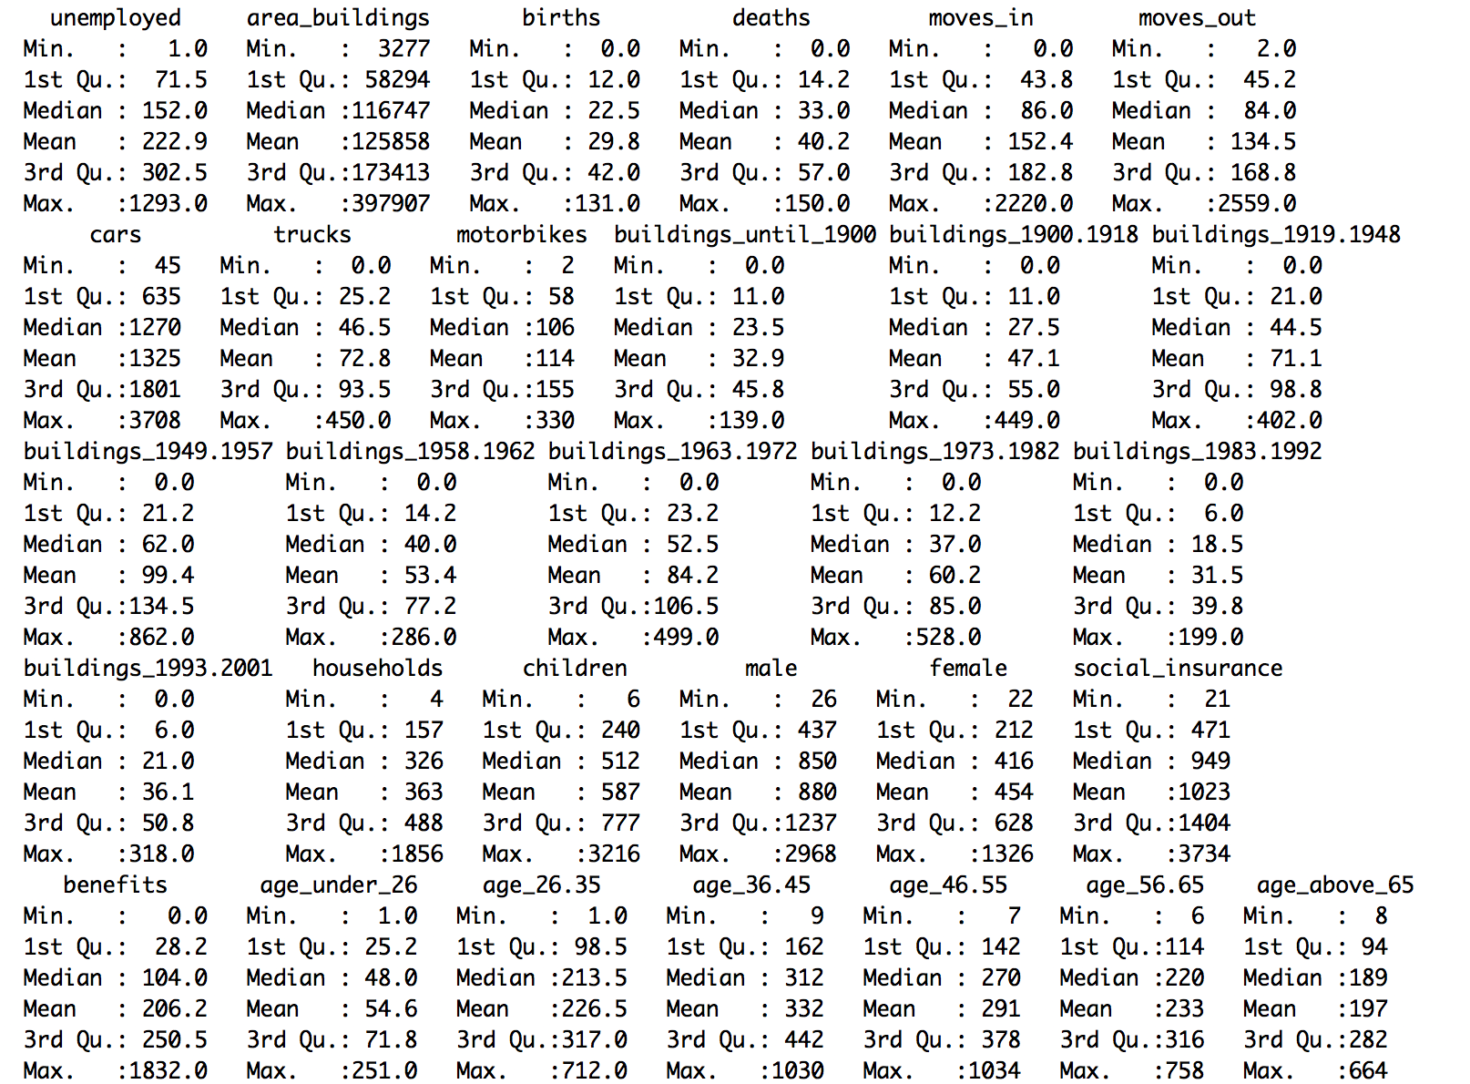

Figure 2: Boxplots (red points = means)

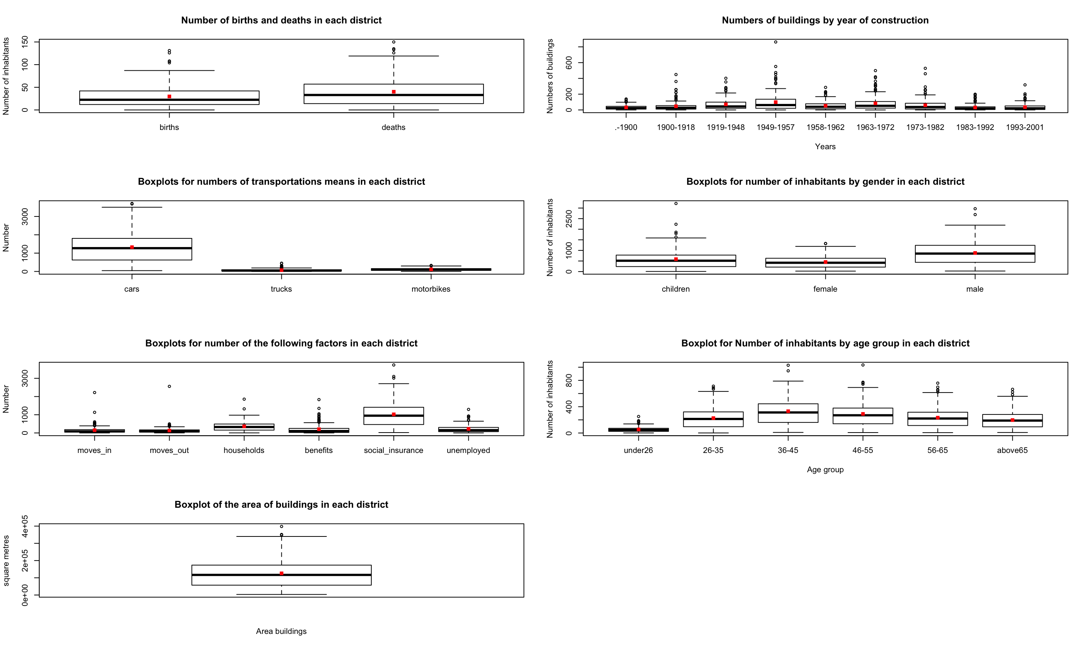

Figure 3: Correlation table Figure 4: pairs plots of age and buildings



Figure 5: Some examples of the high correlated variables (red lines are the fitted loess lines)



Figure 6: MDS plot for building with correlation dissimilarity



Figure 7: PCA outputs for different groups of variables

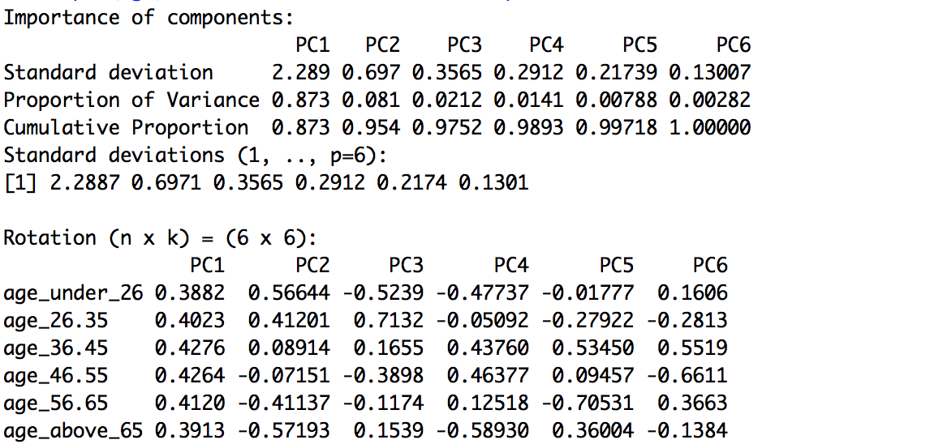 (age)

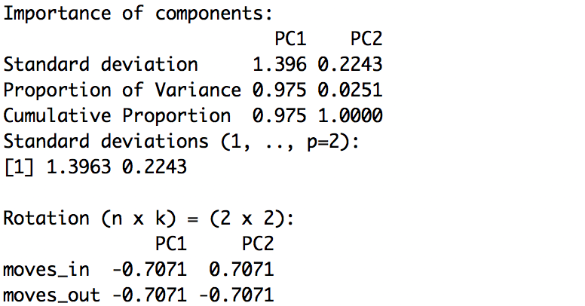

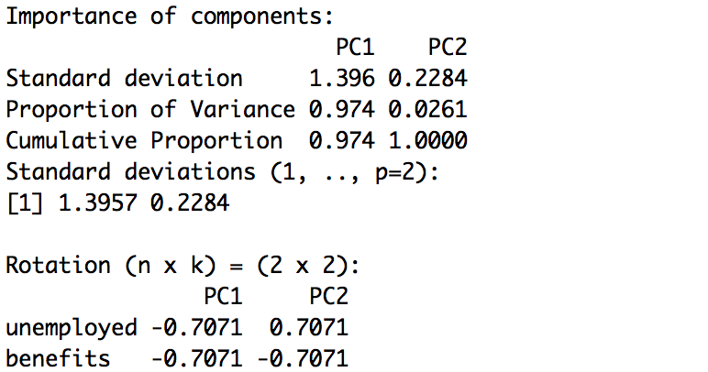

(left: moves, right: unemployed & benefits)

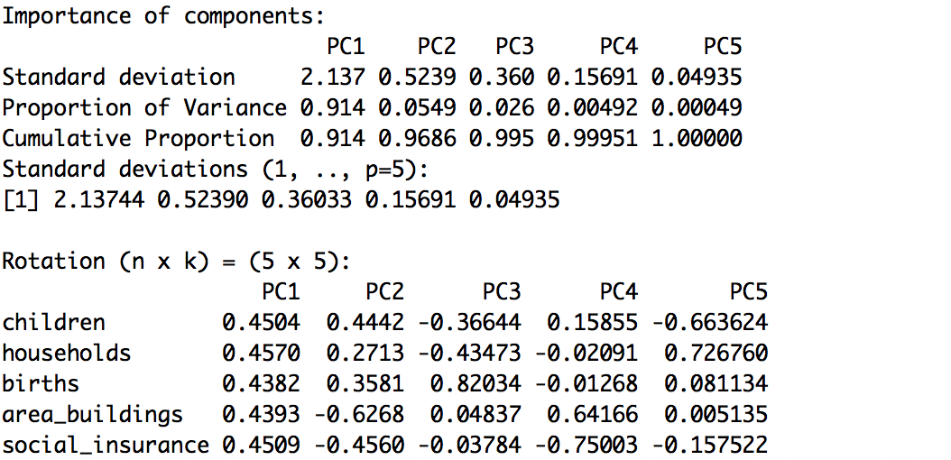 (children, households, births, area_buildings and social insurance)

Figure 8: Plots of Gap statistics



Figure 9: kmeans clustering visualization with k=11

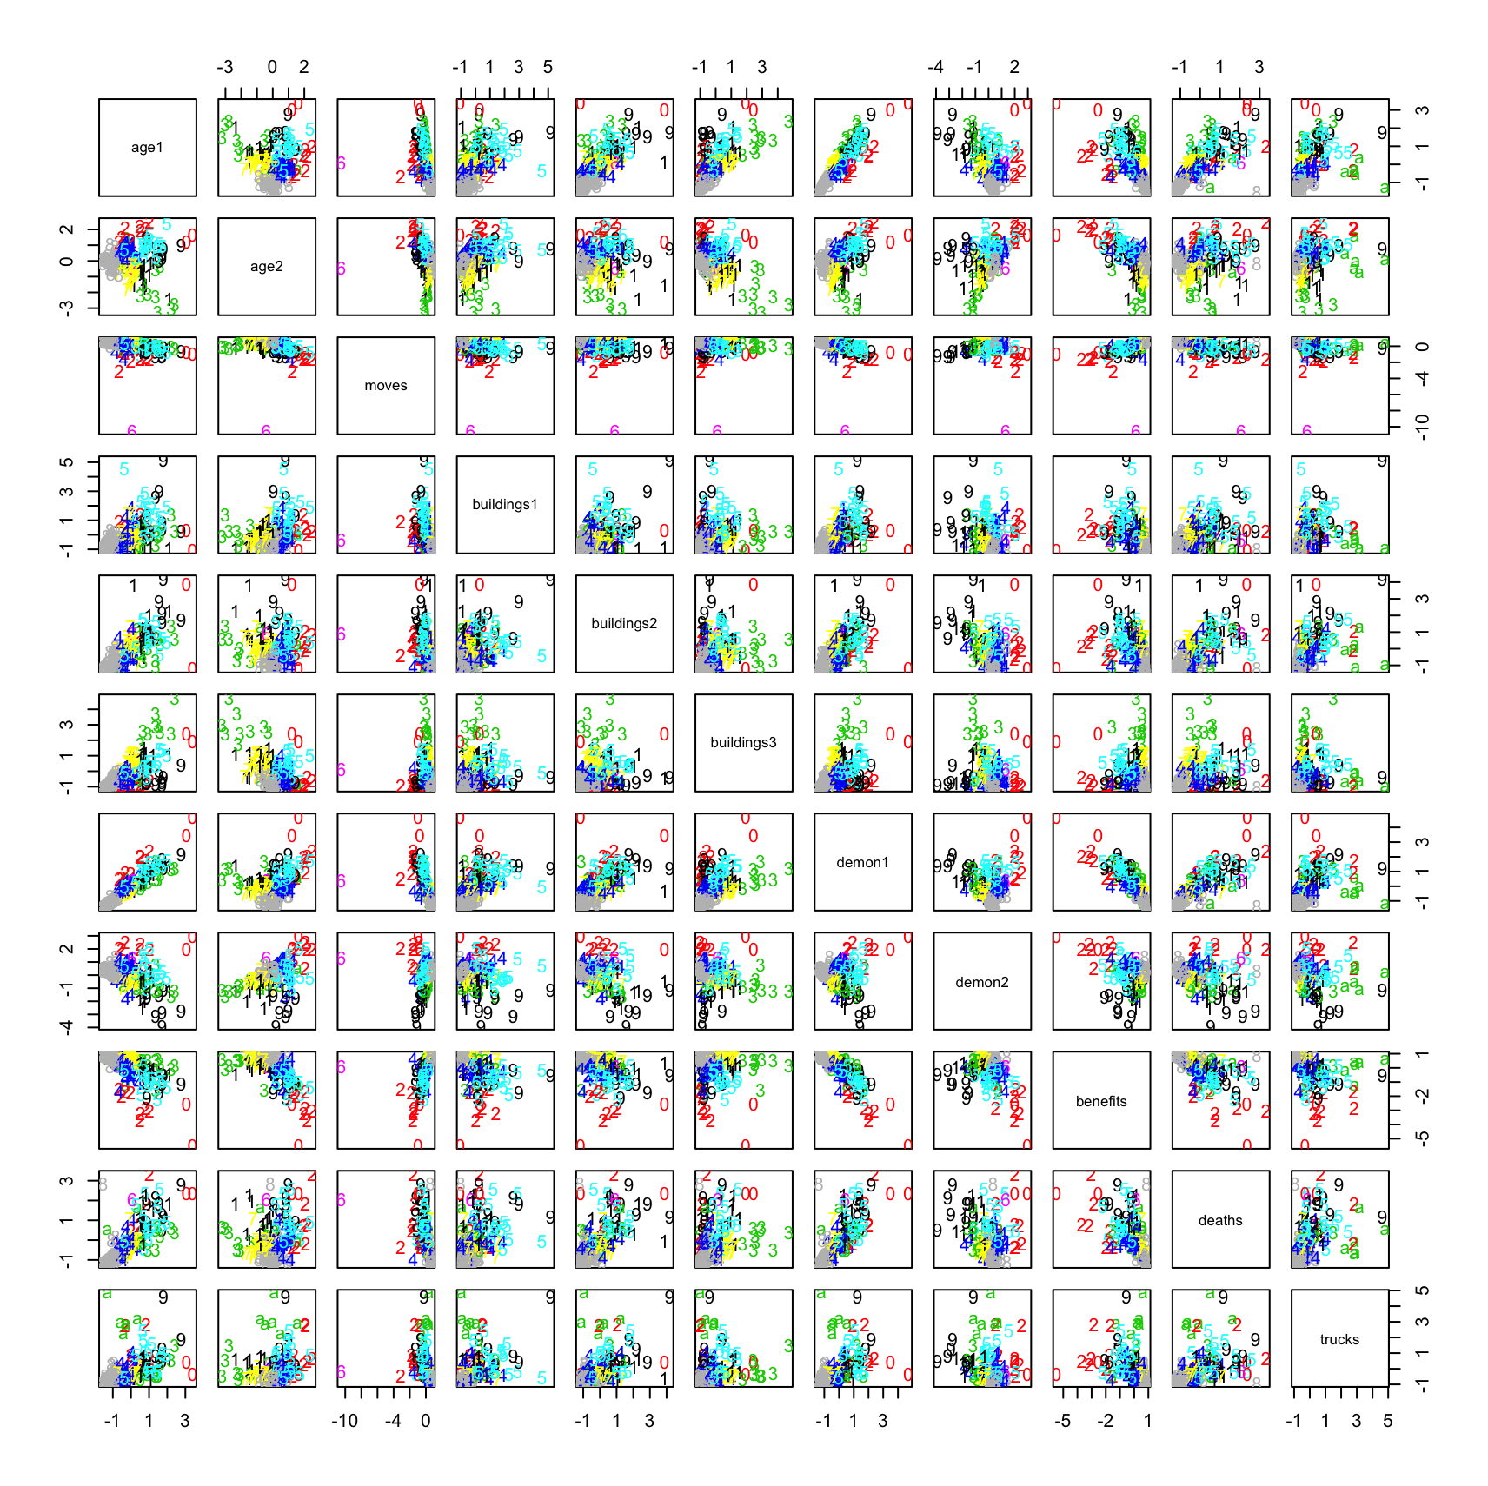

Figure 10: kmeans centers with K=11

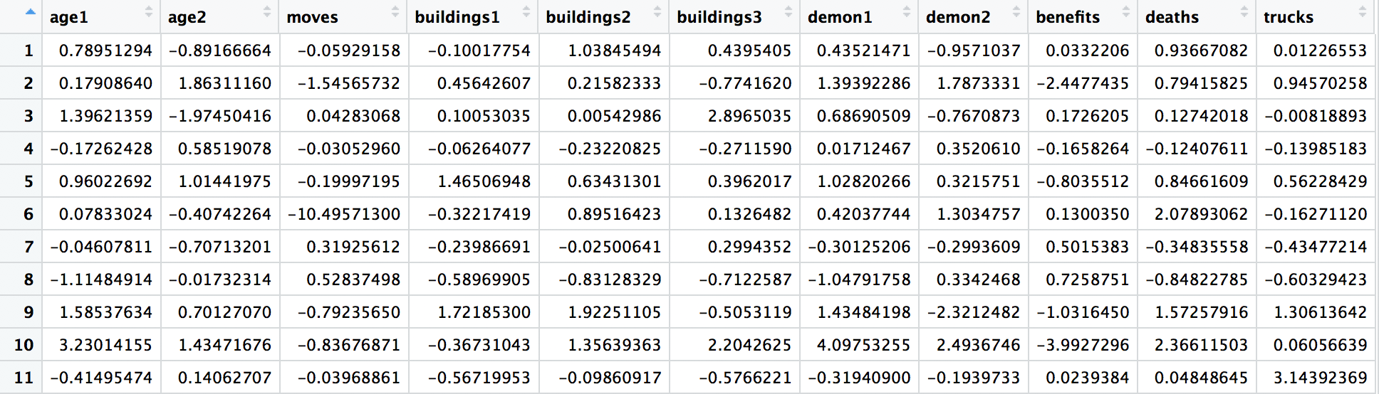

Figure 11: kmeans visualization with K=4

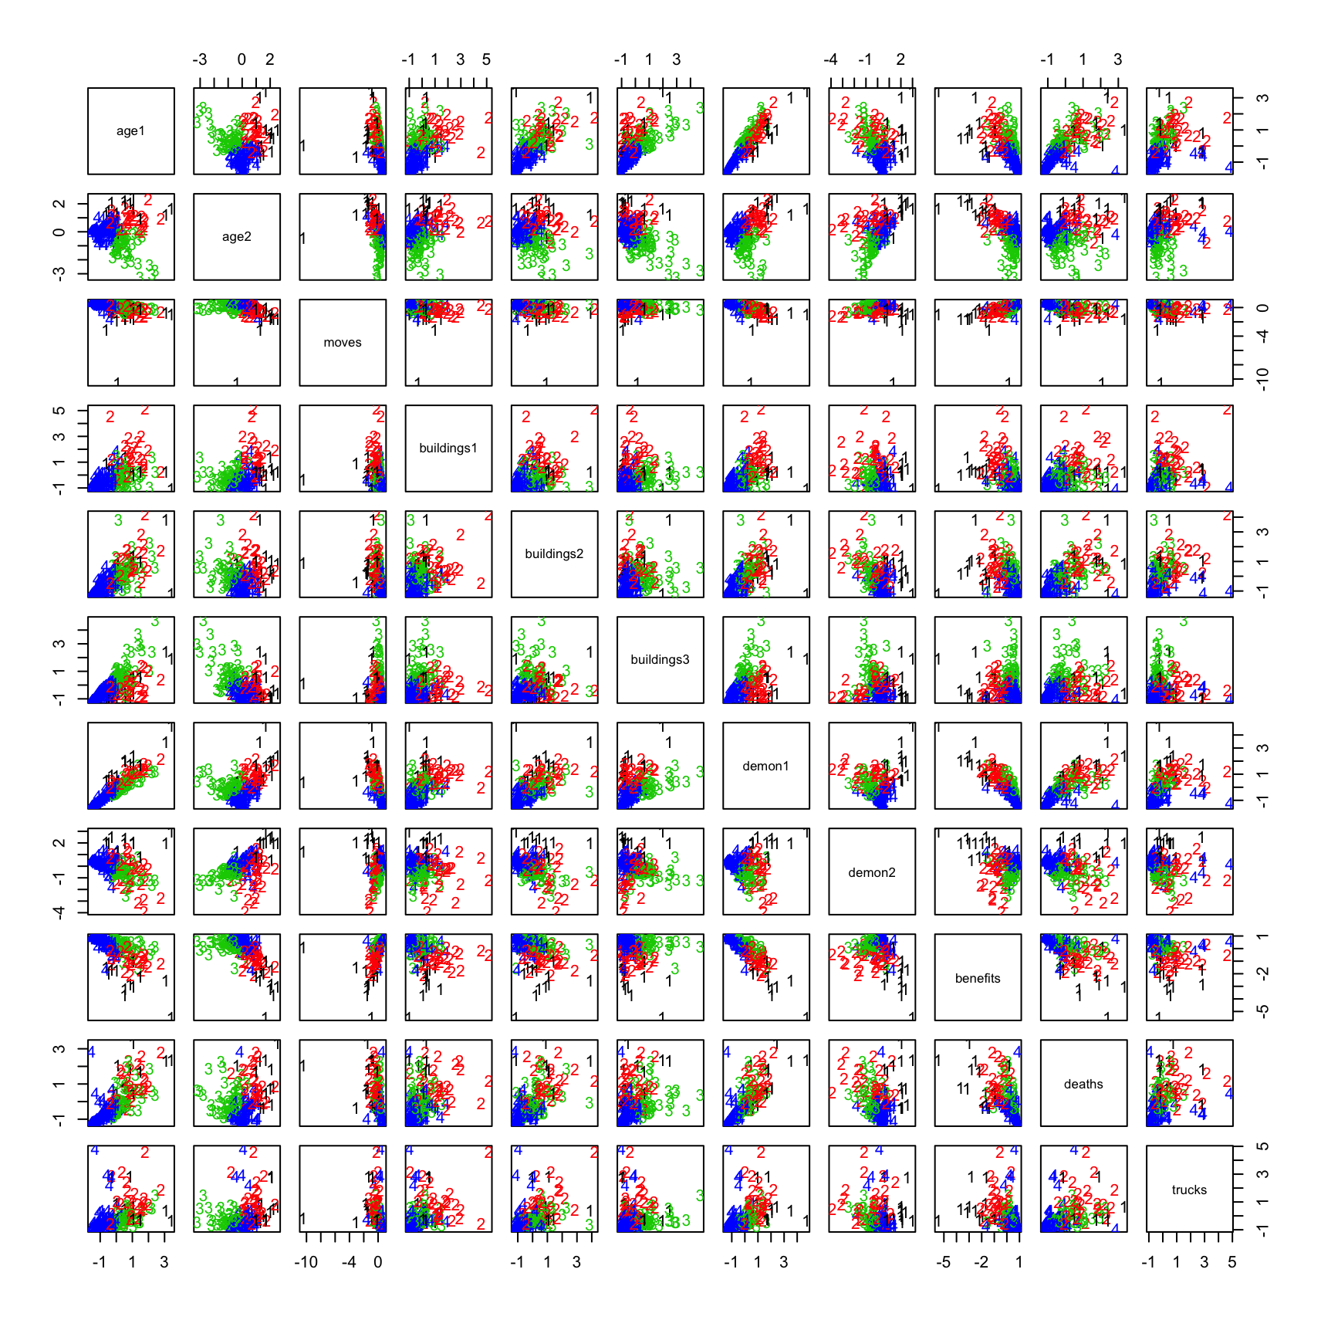

Figure 12: kmeans centers with K=4

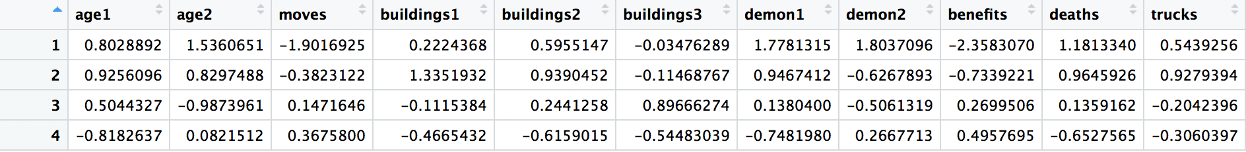

Figure 13: PAM visualization with K=7 (up) and clusters information (bottom)

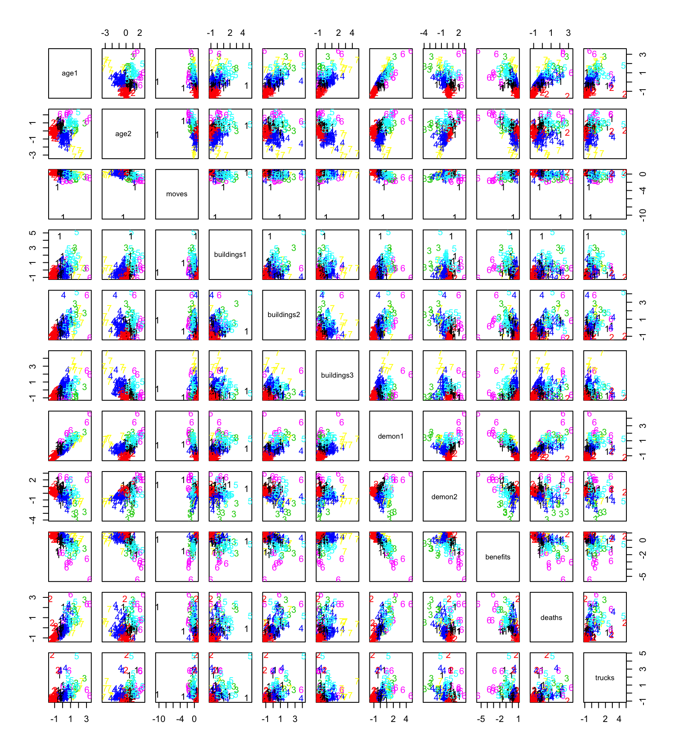

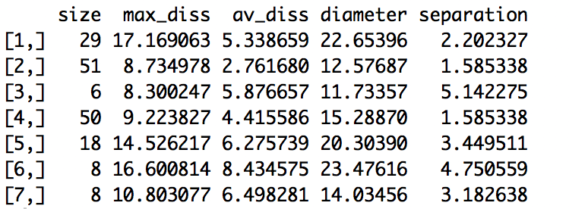

Figure 14: PAM ASW plot

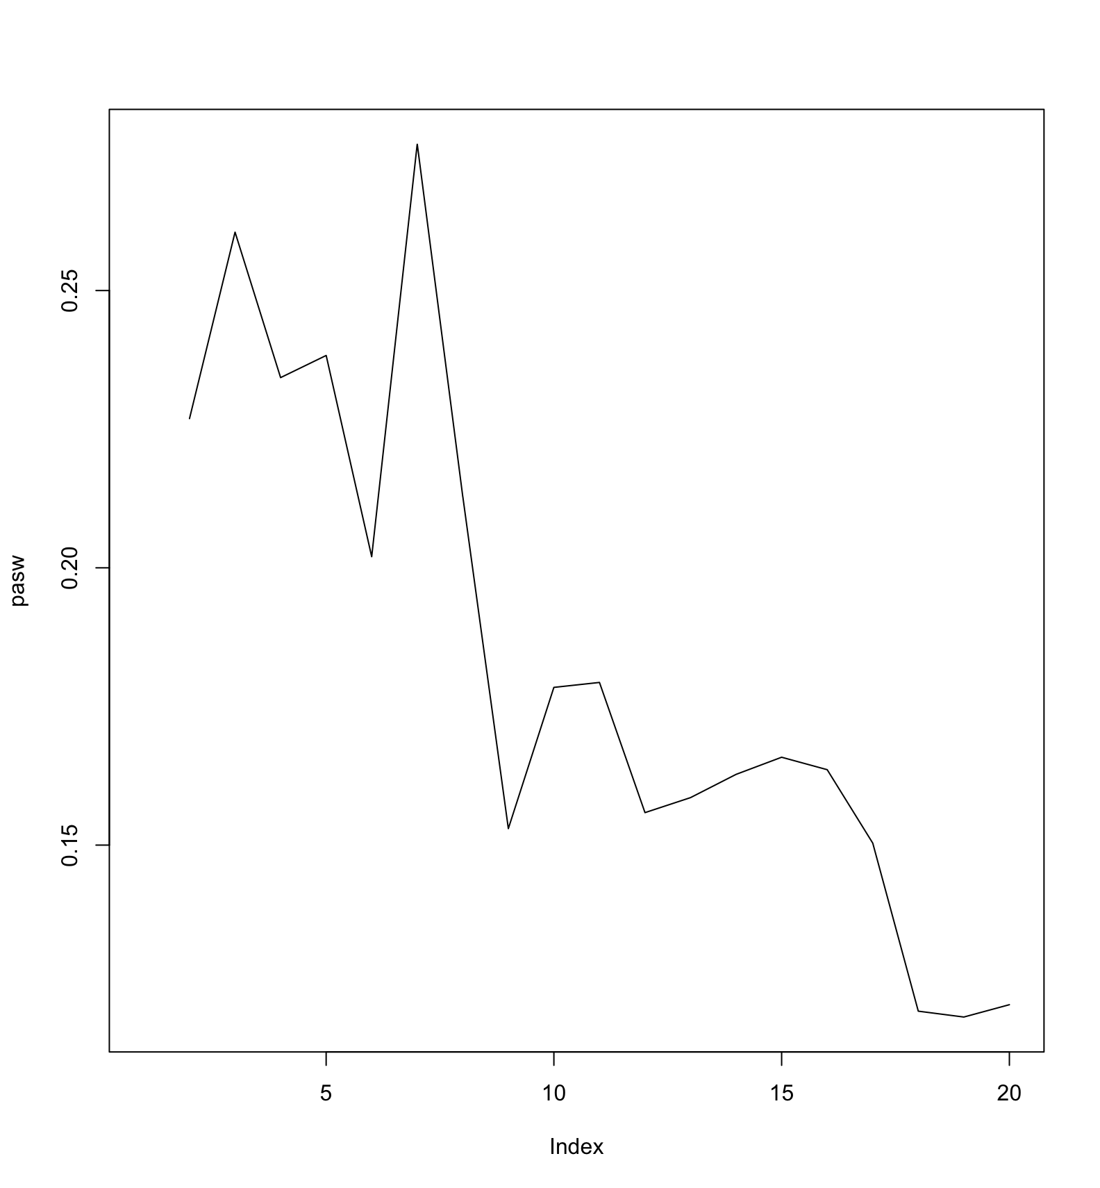

Figure 15: PAM Silhouette plot of K=7

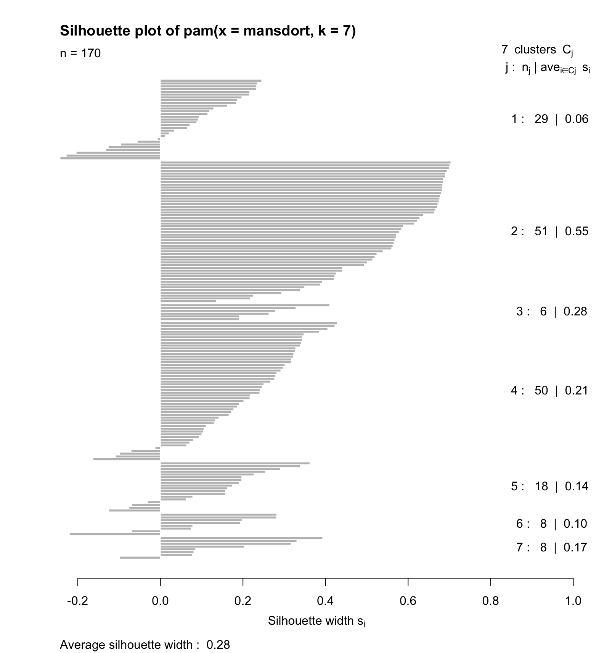

Figure 16: Mclust K=4

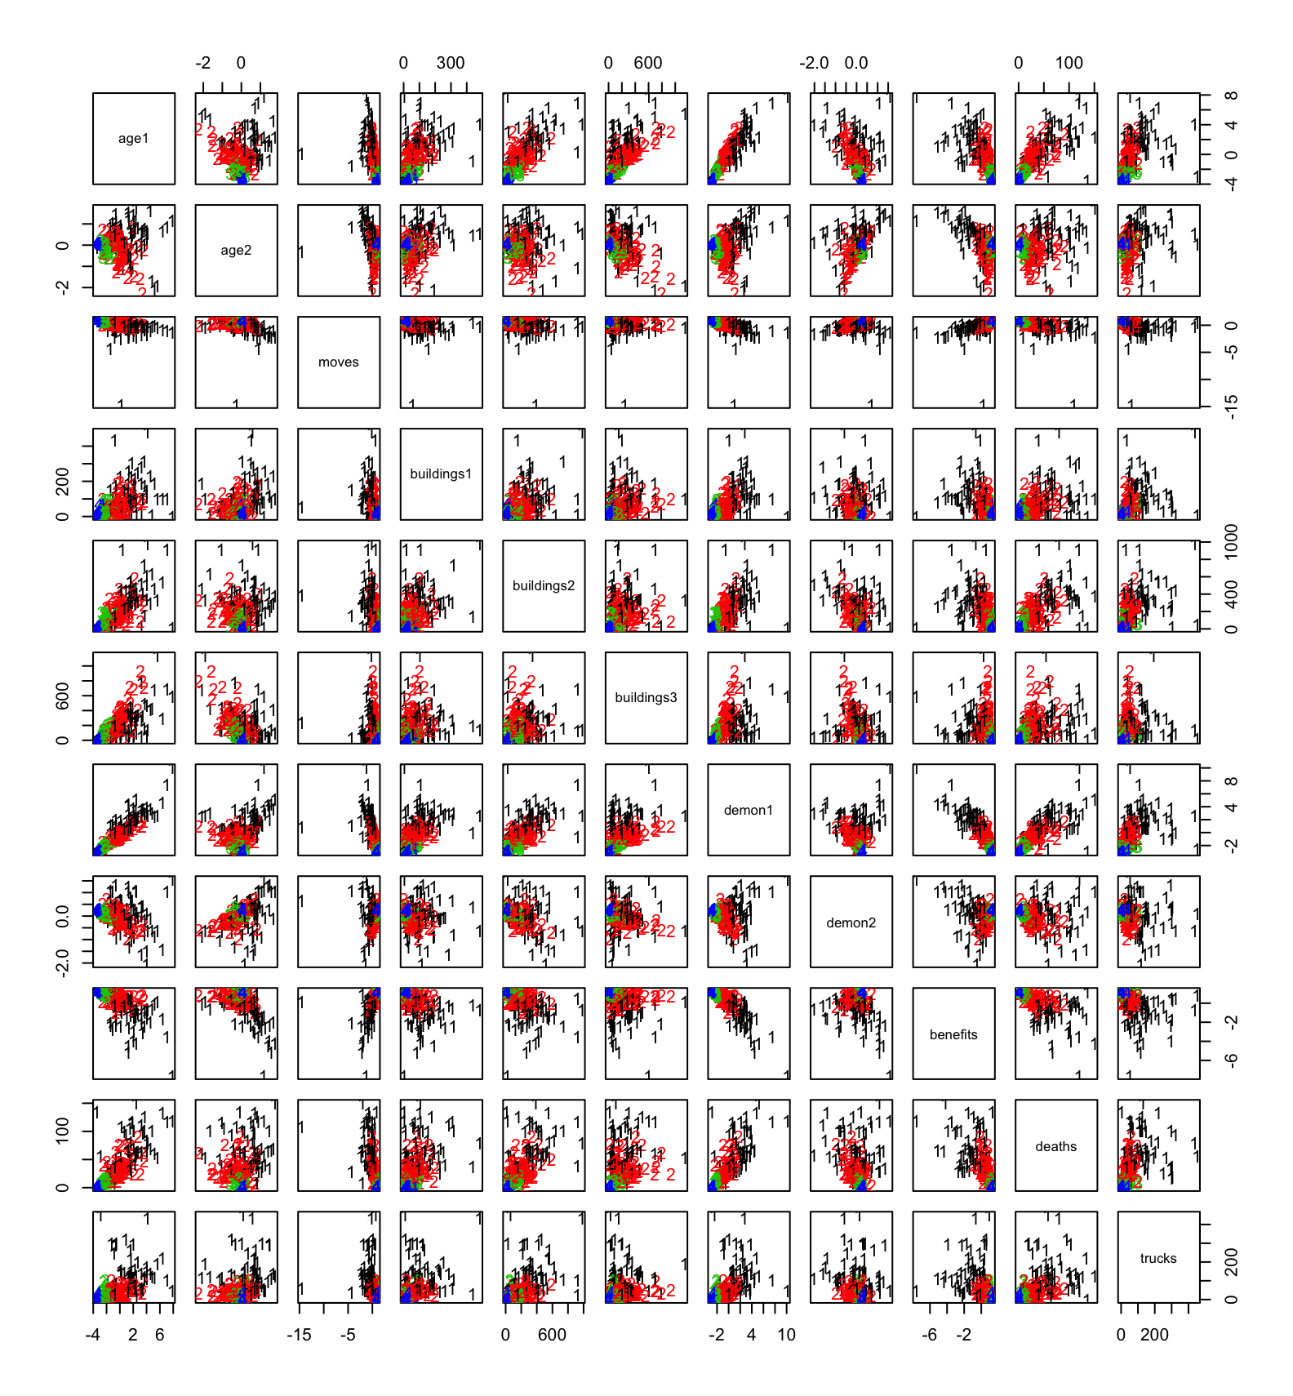

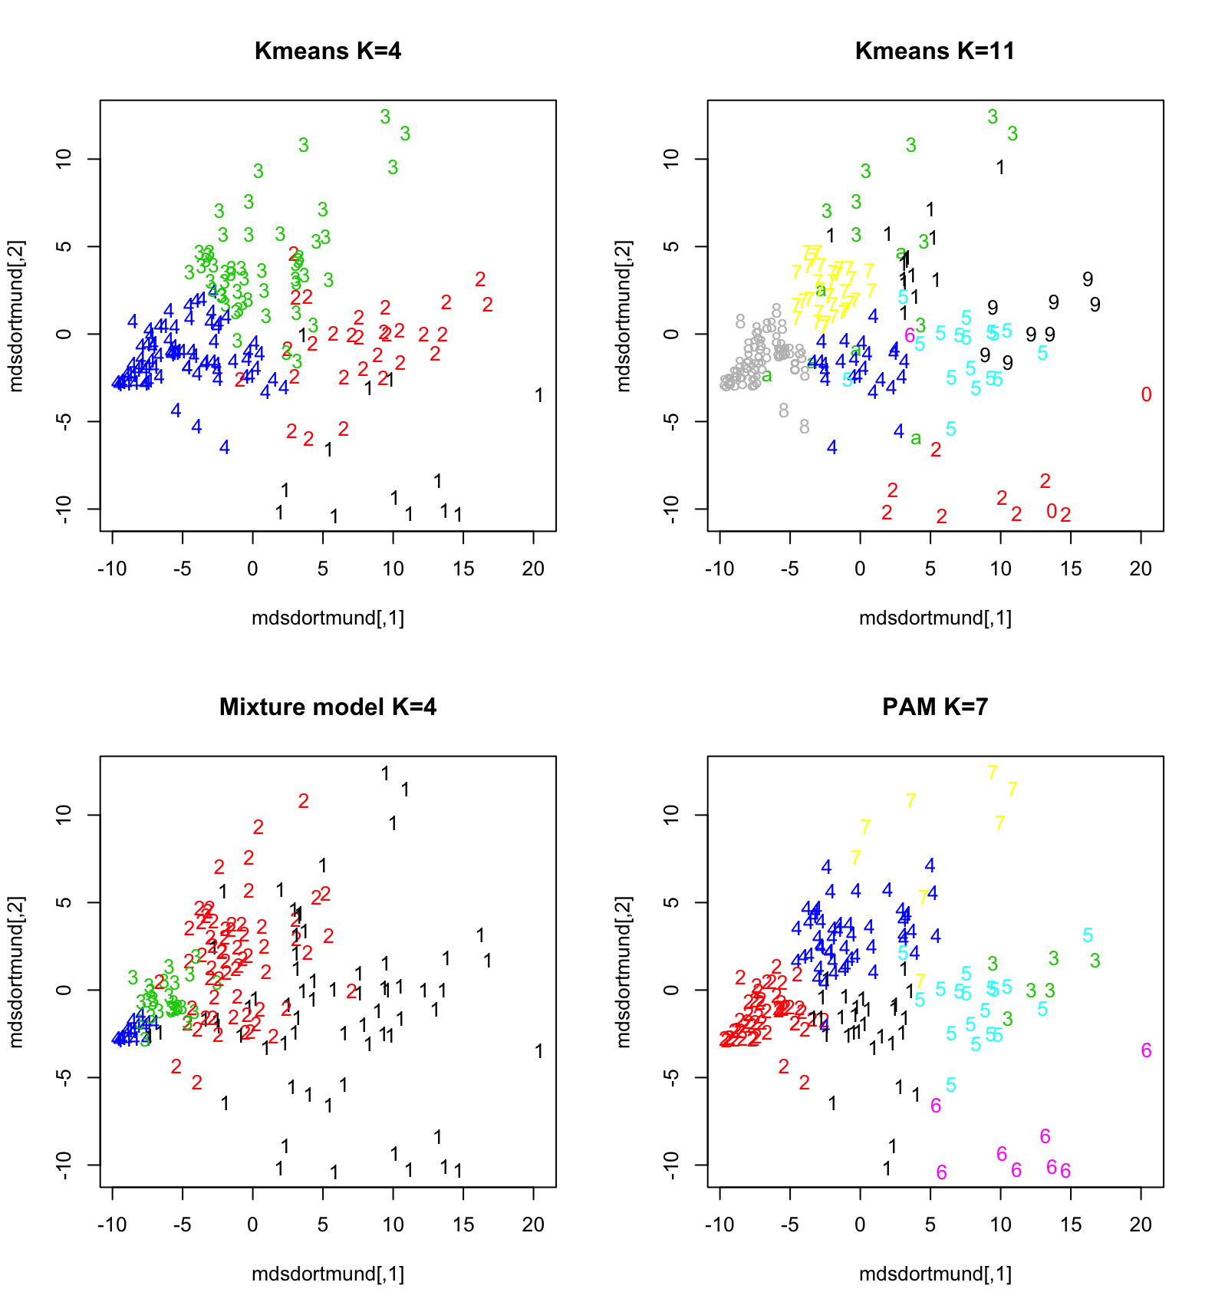

Figure 17: MDS plots with Manhattan distance for: topleft: Kmeans K=4; topright: Kmeans K=11;

Bottomleft: Mixture Models K=4; Bottomright: PAM K=7Figure 18: Visualization in original data

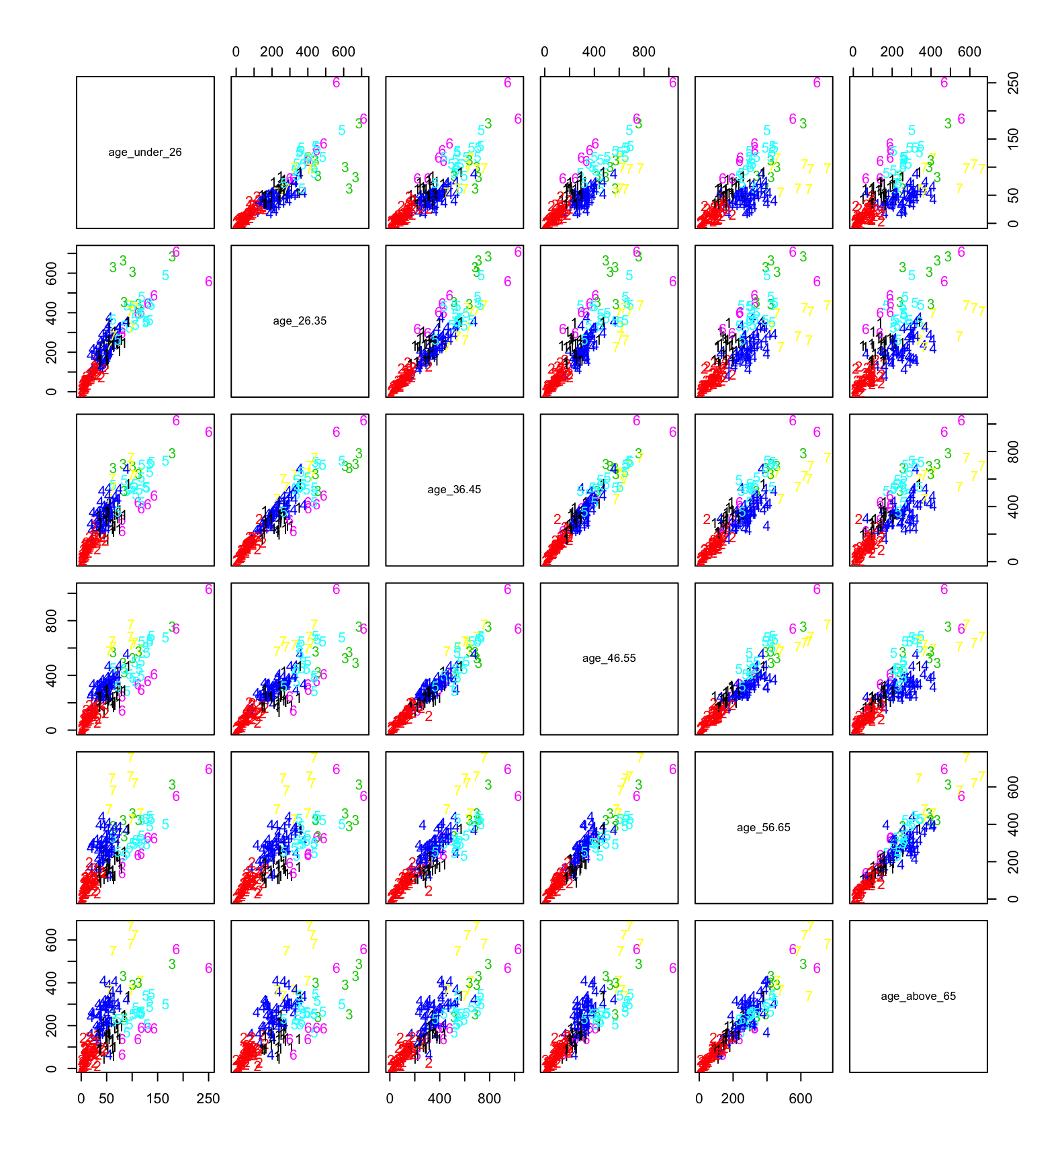(a) age

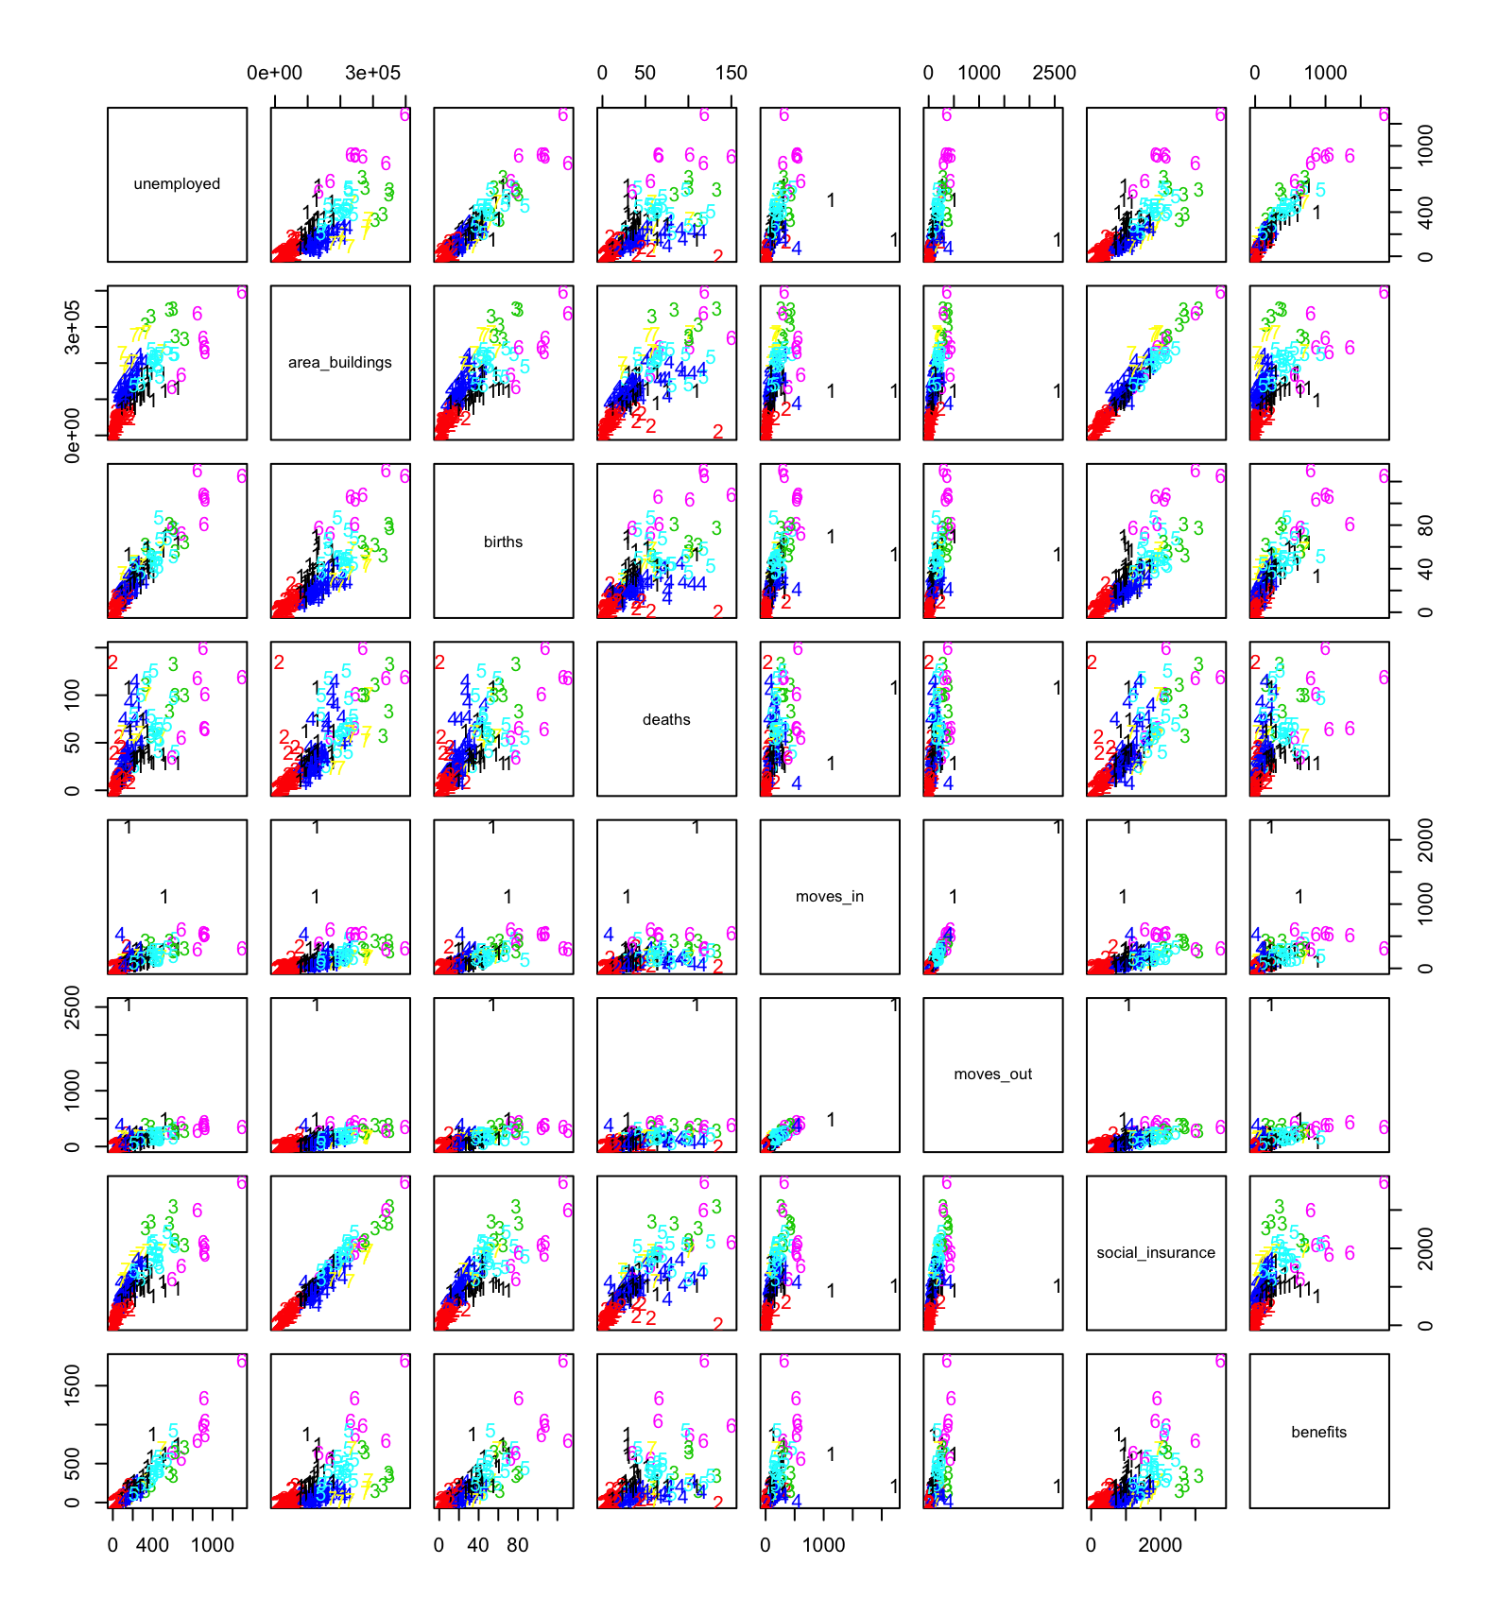(b) demographic

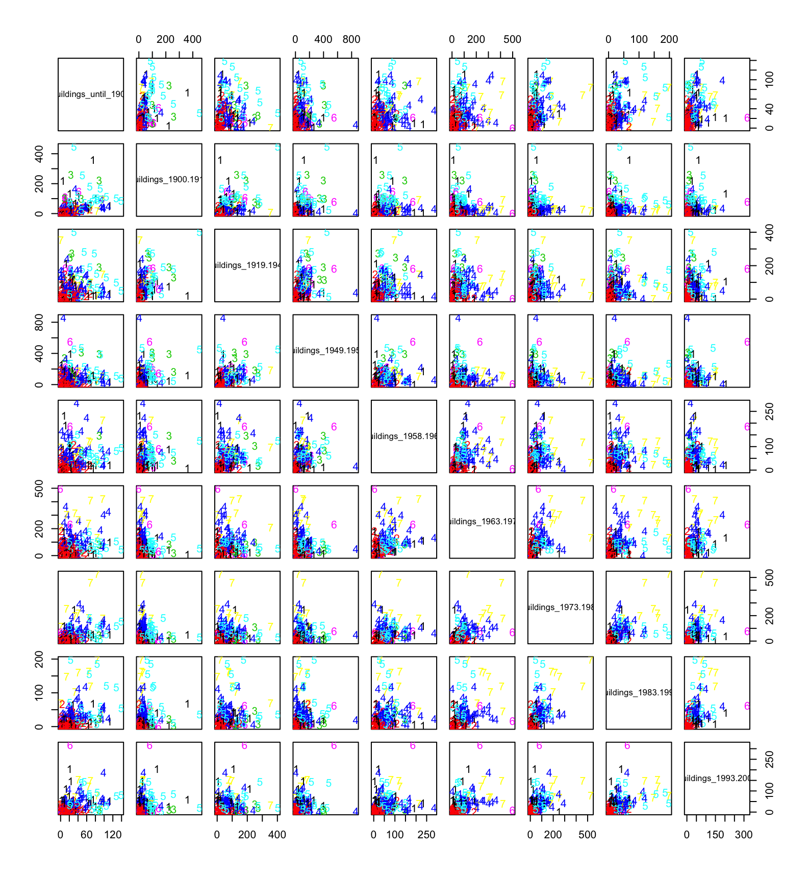 (c) buildings

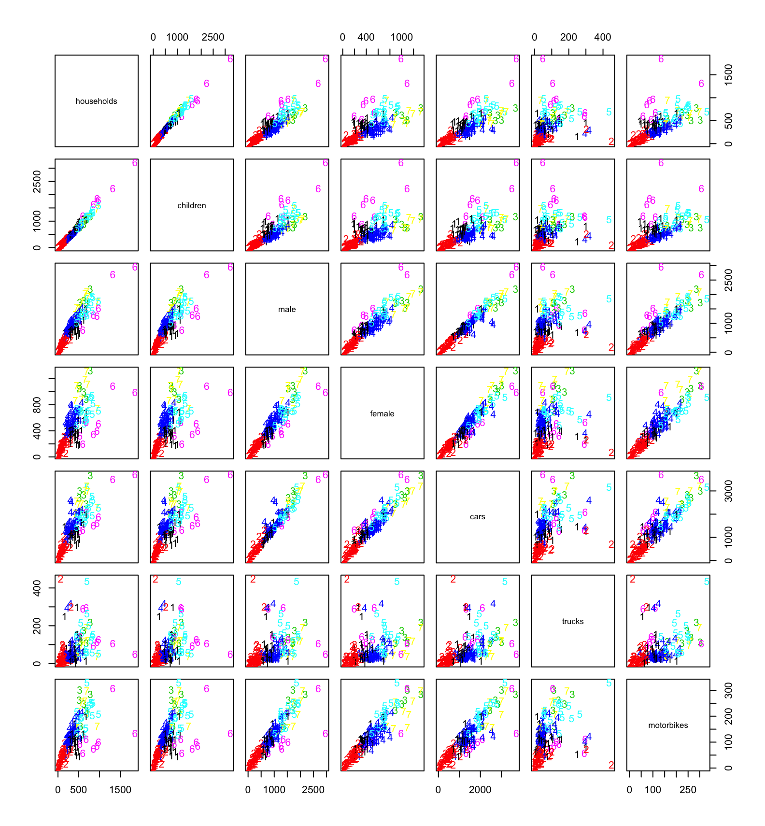 (d) population and transport